**The Holy Family**

The year is finally coming to a close. The weather is getting cooler, the days shorter, and the holiday season is officially here. Despite Egypt being a predominantly Muslim country, you’ll find people all over the country and from all kinds of backgrounds celebrating Christmas this weekend, in addition to the Coptic celebrations of January 7th. But this should really come as no surprise. Aside from the fact that we’re more than happy to celebrate just about anything, Egypt has played a central role in the Biblical narrative since the very beginning and the Holy Family’s journey through the country is a crucial part of the country’s religious and spiritual heritage.

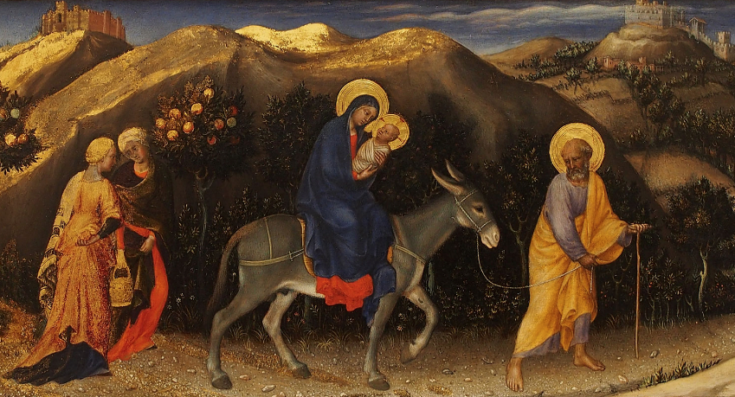

The Gospel of Matthew in the New Testament recounts the story of Mary, Joseph and baby Jesus as they took flight from Jerusalem to seek refuge in Egypt. It is said that when the Magi went to Jerusalem in search of Jesus, they went to King Herod asking for the newborn “King of the Jews”. Herod of course saw this as a direct threat to his own rule and set out to find and kill the child.

According to the Gospel, an angel appeared to Joseph to warn him about the danger of staying in Jerusalem and advised him to leave with his wife and young son to Egypt, a common practice at the time for people looking to escape persecution. Egypt was the perfect place to hide and using the Via Maris – “the way of the sea” – an ancient trade route linking Egypt with the Levant. Throughout their journey in Egypt, the Holy Family passed through more than 26 locations around the country, never staying in one place long; they had to avoid Herod’s spies.

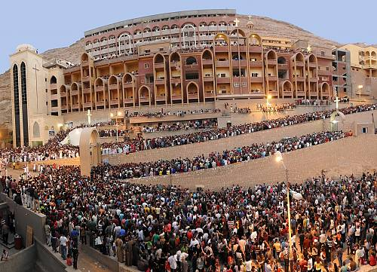

The family’s first stop in Egypt was Tell el-Farama in Sinai, right on the edge of the Delta, followed by Tell Basta, near Zagazig, and Mostorod, a small town also known as al-Mahmma – “the bathing place” – so named because this is where Mary was said to have bathed baby Jesus. They made their way across the Delta, stopping at towns like Belbeis, Samanoud and Sakha, leaving behind small traces in each around which churches, monasteries and pilgrimage sites were eventually built and to which thousands will flock to each year. From the Delta they travelled to Wadi Natroun, an area that used to have one of the highest concentrations of monasteries in the world – now only four remain – and from there, they moved southward to the Cairo neighborhoods of al-Matariyah, Ain Shams and al-Zaitoun. Old Cairo, known at the time as Babylon, would be their next stop.

